TITLE OF CONVR CONFERENCE PAPER (STYLE HEADING 1)
Given name Surname, Title (style author)
Affiliation
email and http
Given name Surname, Title
Affiliation
email and http
ABSTRACT: Place your abstract here. It should be about 250-300 words (Normal Style, italic). A journal article header is built of the following parts: Article title: The title must be in uppercase, 14pt bold. It must fit on a maximum of two lines. It is formatted as heading 1 style. A list of authors with affiliations: For each author three lines are suggested, followed by a blank line separator. First line: author's first name, middle name initial and last name followed by title; second line affiliation, last line electronic address. 10pt bold italic, Address style. Abstract: Following bold and uppercase word "ABSTRACT:" on the same line should begin the 250-300 word summary of the article in 10pt italic.
KEYWORDS: Following the bold, uppercase word "KEYWORDS:" on the same line are up to 7 keywords describing the article in 10pt italic.

PRINCIPLES (FIRST LEVEL HEADINGS: STYLE HEADING 2)
This is normal text. Normal style is used for this text. This conference paper style is (largely) adapted from the formatting instruction and layout for the ITcon journal. See also the following URL:
http://www.itcon.org/cgi-bin/news/Show?_id=22&sort=TIME&search=&hits=22
The default font is Times or Times New Roman in 10pt size. Paragraphs should be flushed left, with space between paragraphs. This template file sets the space automatically. (It works on MS-Word). Bold style is used in all titles, not to be used for emphasized words within the paragraphs. Italic should be used for it.
Articles must be formatted in such way that they can be printed on A4 paper (297 x 210 mm). Margins are all 25 mm. Text must be set in a single column. The header and footer area is set at a margin of 12mm, do not use this area. Figures, etc. must occupy full width of the column and must not be set floating into the text.

Body elements (Second level headings: Style Heading 3)

FIRST LEVEL HEADINGS (Third level headings: Style heading 4)
12pt bold, upper case. Style heading 2.

Second level headings
12pt bold. Style heading 3.

Third level headings
10pt bold. Style heading 4
Table 1: Tables must have a table caption on top of the table, followed by table lines and columns. Tables must have horizontal lines only. Text in tables must be 8pt or bigger.
 | Jan. | Feb. | Mar. | Apr. | May | Jun. | Jul. | Aug. | Sep. | Oct. | Nov. | Dec.
Sendai Average Temperature | 0 | 1 | 4 | 9 | 14 | 18 | 22 | 24 | 20 | 14 | 8 | 3
Ave. Minimum Temperature | -4 | -4 | -1 | 4 | 9 | 14 | 19 | 20 | 16 | 9 | 3 | -1
Ave. Maximum Temperature | 4 | 5 | 8 | 14 | 19 | 22 | 25 | 27 | 24 | 19 | 13 | 7
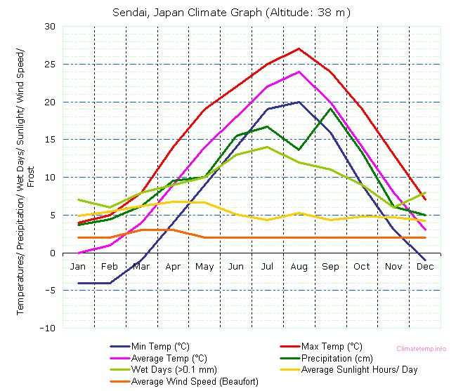
Fig. 1: Use of figures and graphics is encouraged. So is the use of color but make sure that they print well on black and white printers. If possible, the figures should be in a vector format. Figure captions are placed below the actual graphic. We suggest short captions (one line) and a detailed discussion of the figure in the text.

REFERENCES (STYLE HEADING 2)
References must be sorted alphabetically in the section "References". Modified Harvard style of referencing must be used. For example:
Jones A.S. (1994a). The future of electronic publishing, Journal of modern communications, Vol. 3, No. 5, 213-232.
Smith A.S. and Jones A.B. (1994). Publish electronically, Proceedings of 4th international conference of office systems (Jones A.B., editor), University of New Brunswick, 213-232.

